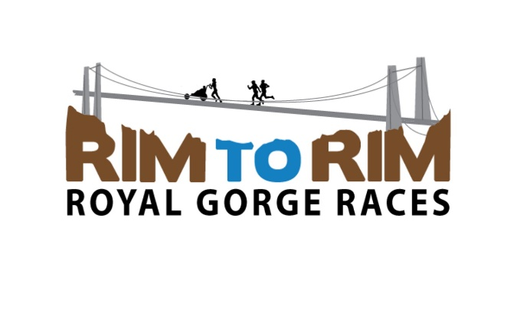

STRAPOINT RIM TO RIM ROYAL GORGE RACES
REGISTRATION FORM – TODDLER TROT/KID’S RACE

Race: _______Toddler Trot ________Kid’s ½ Mile Race
Participant’s Last Name: ____________________________ First Name: _________________________
Address: _____________________________________________________________________________
Gender: ________ Male ________ Female Age on Race Day: ________ DOB _______________
WAIVER: In consideration of Starpoint accepting this entry (application) form, I, the undersigned, intending to be legally bound, hereby, for myself, my family, my heirs, my executors, and my administrators, forever waive, release, and discharge any and all rights claims or suits, known or unknown, that I or they have or may have against the organizers of this event, the city of Canon City, Colorado, the county of Fremont County, Colorado, Starpoint, the Royal Gorge Bridge and Park and all race officials, volunteers and sponsors of the race for any and all injuries suffered by me and/or my minor child or children in this event. I attest that I, or my minor child, am physically fit and am aware of the precautions that must be taken for the event. I give consent for my image to be used on the Rim to Rim Royal Gorge Website and/or promotional materials.
I have read the information provided and certify my acceptance of the same by signing below.
Parent/legal guardian name (please print): __________________________________________________
Parent/legal guardian signature: ______________________________________ Date: _______________

